UTBackup Cloud Project Charter

UT Backup Cloud Project

Executive Summary
The UTBackup Cloud Project will deliver the UTBackup service on a cloud platform. This project includes refining the current state of stale device management with support from the Information Security Office and Records Retention Policy.

Business Need and Background
UTBackup appliances will reach end of support and user licenses will be at end of term on September 1st of 2019. ITS must transition nearly 9,000 end users to the Code42 cloud-based backup solution before that date. Code42’s cloud solution will improve the universities backup stature through greater geo-location with off-site backups.
This project brings the UTBackup service in line with the industry standard of cloud backups by the ultimately meeting the following FAS Portfolio goals:
- Stewardship – We are exceptional caretakers of the resources entrusted to FAS.
  - Increased efficiencies and savings: The end-point backup industry is moving to a more cloud centric model, running on premise backup products is becoming exceedingly costly as it becomes a more niche product.
- Service – We are customer service oriented and offer responsive, reliable and seamless support.
  - Improved service: There will be great strides in support of the UT Austin account as our service falls more in line with the standard service delivery for Code42, thus improving the product we are ultimately able to deliver to the greater University community.
- Innovation – We are creative and innovative in our service to the campus community.
  - Keeping up with industry trends: End-point backup products are currently developing greater functionality for integration with cloud services. Utilizing cloud backup products opens the doors for the University to leverage innovation within the data assurance field.

Project Description and Scope

The aim of this project is to connect all active UTBackup end-points to the Code42 cloud destination. All end-points will be creating a new backup in the cloud. During the duration of the project backups will be running parallel to the cloud.
IN SCOPE
- Enforcing the adoption of the Cloud Destination for all active UTBackup users
OUT OF SCOPE
- Retirement of unsupported hardware
- Data Migration

Project Goals
The UT Backup project will be considered successful by meeting the following criteria:
Migrate CSU’s to the cloud.
- All deployment documentation has been created, reviewed and approved
- All operational documentation, including MOU and SLA documentation has been created, reviewed and approved, including creating a data retention policy.
- Additional criteria

Project Schedule
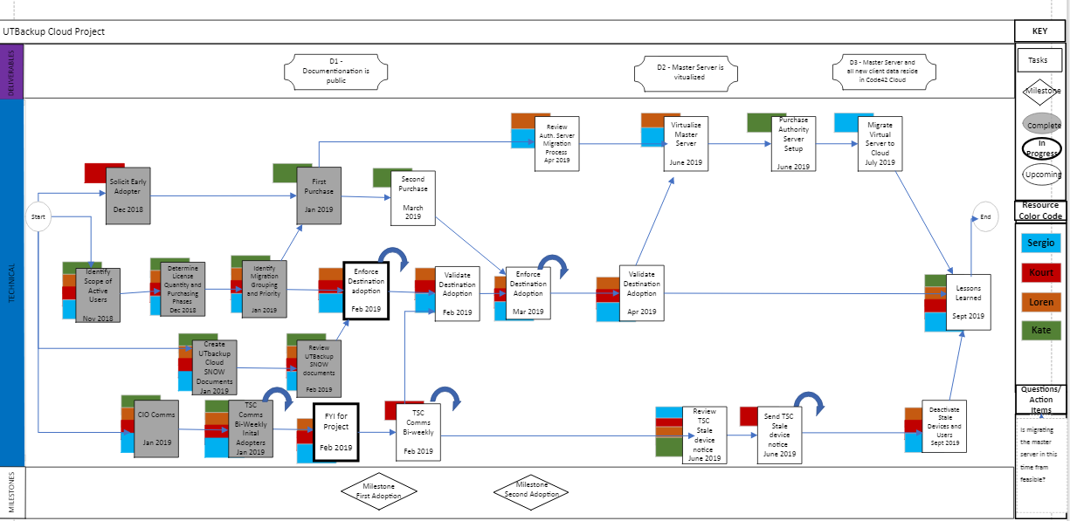
PHASE | FTE | Q4 2018 |  |  | Q1 2019 |  |  | Q2 2019 |  |  | Q3 2019
 |  | Oct | Nov | Dec | Jan | Feb | Mar | Apr | May | June | July | Aug
Plan | 1
Requirements | 1
Test | 4
Train | 1
Deploy | 1

Project Costs

Budget Item | Cost
Hardware/Equipment | $0
Software and Licensing | $144,000
Training | $0
Consulting | $0
MO&E Other | $0
FTEs - Capital | $117,550
FTEs – Expense | $47,100
Total | $311,650

Budget Item | Cost FY 1 | Cost FY 2 | Cost FY 3
Hardware/Equipment | $29,229 | $0 | $0
Software and Licensing | $192,000 | $197,760 | $203,712
Training | $0 | $0 | $0
Consulting | $0 | $0 | $0
MO&E Other | $0 | $0 | $0
FTEs | .35 | .25 | .25
Total | $228,229 | $202,760 | $208,712

Project Management and Governance

Role | Name(s)/Organization(s) | Responsibilities
Executive Sponsor(s) | - Trice Humpert, Director ITS Sys  - Susan Roy, Director, ITS CSS | - Project champion  - Owns the business case at senior staff level  - Keeps project aligned with organization's strategy and portfolio direction  - Escalation point for non-user facing system implementation decisions
Customer Steering Committee | TBD
Project Manager | Kate Russell | - Liaison to other sponsors and stakeholders  - Track project progress  - Communicate status to stakeholders  - Govern project risks and issues  - Focus on realization of benefits  - Provide assurance to technical project team
Project Manager Advisor | Carol Lee (consulted as needed) | - As needed, provide project leadership support
Technical Lead | Sergio Martin | - Lead detailed system analysis, design, configuration, development of upgrade project.  - Contribute to project initiation efforts by defining project scope and supporting the development of work plans, estimates, and timelines.
Project Team | Kourt de Haas  Loren Schooley | - Assist with detailed system analysis, design, configuration, development of project.  - Support project initiation efforts by assisting in the definition of project scope. Assists project management in the development of work plans, estimates, and timelines.  - Assist with working with customer groups to gather light feedback iteratively.  - Support solution testing efforts by assisting with developing test plans, preparing test environments, performing test execution, and validating test results.  - Proactively identifies and effectively assesses improvement opportunities
Information Security Officer | TBD | - Provide consultation on security requirements, perform security and credential scans on systems and software.
Networking Point of Contact | Needed?
Stakeholder(s) | Top 3 to 5 customers

Impact Analysis
ITS Systems and ITS Customer Support Services will allocate systems administration resources to assist in migrating the service to the cloud.

Assumptions
- The migration will not require any changes to underpinning services provided by the UT Backup service

Risks
Risk
TSCs not understanding the data loss implications of the new UTBackup stale data management practices. Units could fail to meet record retention policies.
Mitigation
Communicating early, frequently and clearly with campus technical support
Risk
Due to faculty vacations, not completing the adoption process before summer break, which would leave many devices with incomplete or missing backups in the cloud.
Mitigation
The project is planned to complete the cloud adoption process by May 1st which is anticipated to be sufficient time to all for faculty to complete backups before summer

Revision History
Version | Date | Updater Name | Description
V 1 | 12/10/18 | Katelyn Russell | Initial draft completed
V1.1 | 1/14/2019 | Katelyn Russell | Revised standards for stale device
V1.2 | 1/24/2019 | Katelyn Russell | Added budget detail

Signatures
Formal written signoff is preferred for larger, more complex projects.
Name | Role | Signature | Date

